TEST EXECUTION REPORT
Project Name: E-Commerce Application
Application: Online Shopping Website
Test Cycle: Regression Testing
Environment: QA
Execution Date: 02-Sep-2026
Prepared By: AI Testing Agent
Overall Status: PARTIALLY PASSED

Report Overview
Execution Summary
Test Execution Results
Failure Analysis
Defect Summary
Quality Assessment
Recommendations
Final Sign-Off

Report Overview
Regression testing was executed on the E-Commerce Application to validate business-critical functionality including login, search, cart, checkout and order placement workflows. The cycle focused on identifying regressions and assessing release readiness.

Execution Summary
Total Test Cases | 20
Executed | 20
Passed | 16
Failed | 3
Blocked | 1
Skipped | 0
Pass Percentage | 80%
Status | PARTIALLY PASSED
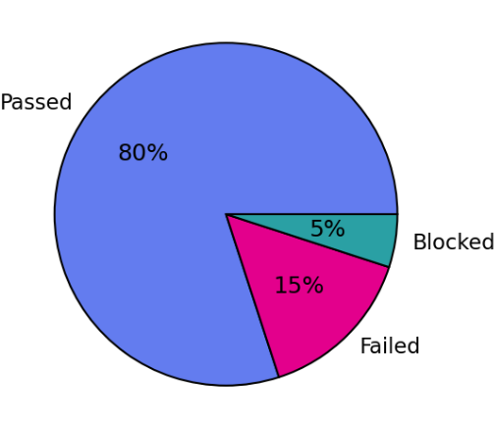
Management Summary: Testing scope covered regression coverage for core customer journeys. Execution completion reached 100%. The application demonstrated stable authentication and product search capabilities; however, order processing and cart update defects prevent release approval.

Test Execution Results
Test Case ID | Test Case | Status
TC-001 | Valid Login | PASS
TC-002 | Invalid Login | PASS
TC-003 | Empty Username | PASS
TC-004 | Empty Password | PASS
TC-005 | Search Product | PASS
TC-006 | Add Product to Cart | PASS
TC-007 | Remove Product from Cart | PASS
TC-008 | Update Cart Quantity | FAIL
TC-009 | Checkout | PASS
TC-010 | Place Order | FAIL

Failure Analysis
TC-008: Medium severity application defect affecting cart quantity updates.
TC-010: High severity application defect causing order submission failure.
TC-015: Low severity automation issue due to missing locator.
Risk Assessment: Order placement failures directly affect revenue generation and customer experience. Immediate remediation is recommended.

Defect Summary
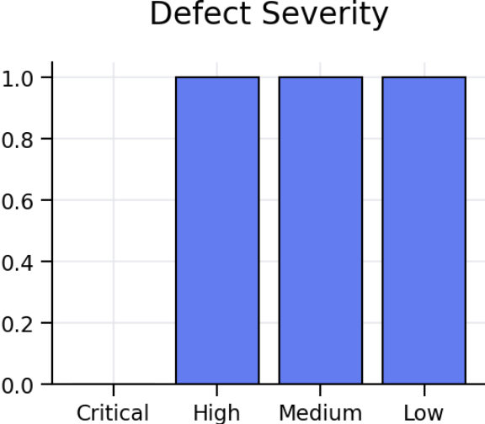
Critical:0 High:1 Medium:1 Low:1 Total:3. Quality trend indicates manageable defect volume but presence of a high severity issue blocks production deployment.

Quality Assessment
Functional Coverage: Complete
Regression Coverage: Complete
High Severity Open Defect: Yes
Login Module: Stable
Order Module: Requires Immediate Attention
Area | Risk Level | Status
Login Module | Low | Stable
Search Module | Low | Stable
Cart Module | Medium | Requires Fix
Checkout Module | Medium | Requires Validation
Order Module | High | Critical Attention

Recommendations
1. Fix order submission defect.
2. Investigate cart quantity issue.
3. Resolve automation locator failures.
4. Re-execute failed tests.
5. Perform full regression and smoke validation before deployment.

Final Assessment
Overall Result: PARTIALLY PASSED
Recommendation: Release Not Recommended
Reason: One high severity defect impacts order placement functionality.

Final Sign-Off
Role | Name | Signature | Date
QA Engineer | AI Testing Agent | ________ | 02-Sep-2026
QA Lead | ________ | ________ | ________
Project Manager | ________ | ________ | ________

